**Appendix E**

**Legal Texting Exercise**

Student Directions: After the assigned introductory reading, review the email below from your supervisor on the Mile High/Daniels matter.* As they request, text the client an update. His phone number is 339-793-8740. The text must be sent by 3 p.m. on Monday, November 21. Note he (the client) may not have your cell phone number saved in his phone, so mention who you are in the text.

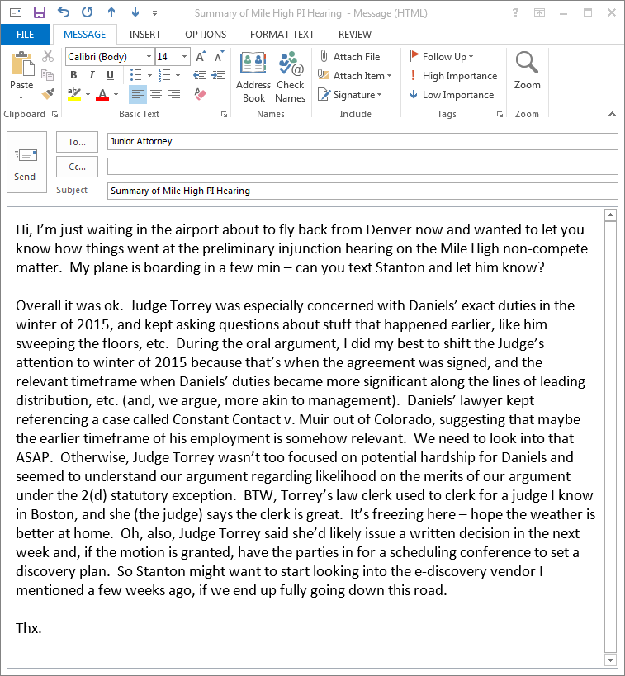

* The hypothetical case content in this exercise is specific to a particular memo writing problem and can be adjusted to fit the context of any student research and writing project in the legal practice course.